Materials and Method

The solar dryer is installed at BMS College of Engineering, Bangalore (latitude of 12.9410° N, longitude of 77.5655° E).

**Description of the direct solar dryer**

|  |  |  |  |
| --- | --- | --- | --- |
| **S.NO.** | **Instruments** | **Model no.** | **Specifications** |
| **1.** | Hygrometer | STC 2 | Accuracy +/- 5% |
| **2.** | Anemometer | HTC AVM-07 | Least count- 0.1 m/s |
| **3.** | IR Thermometer | AP-IS11A001 | Temperature measurement accuracy:±1°C |
| **4.** | Weighing balance | SF 400 | Least count- 1 g  Max weight:10kg  Maximum weight- 10 kg |

The experimental set-up consists of a solar dryer made of aluminium frame. The solar dryer is provided with an insulated casing at the bottom. The inner tray area of the solar dryer is one (m)^2. The high side of the tray is 0.502 m and low side 0.184 m in length. A glass cover 0.005 m thick and inclined at 2.13degrees to the horizontal was used to decrease direct convective heat losses. The schematic arrangement of the solar dryer is shown in figure 1.

Table 1: Solar dryer

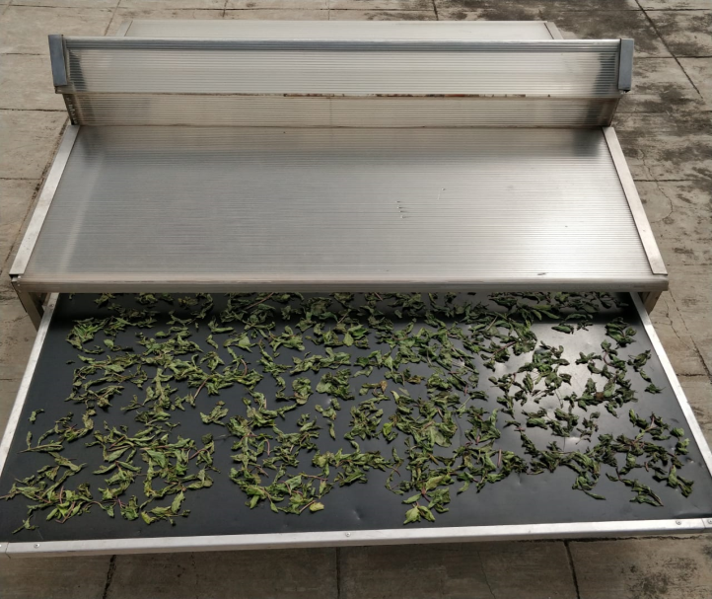

Figure1: Solar dryer

Experimental procedure

Fresh spinach leaves (Spinacia Oleracea) were procured from a local market in Bangalore, India. The leaves were cleaned by removing undesired stems and waste materials. A sample size of 300g of uniform sized green leaves were selected for the experiment. The experiment was conducted to study the thin layer drying behaviour of spinach leaves using solar dryer.

*Analysis of drying characteristics*

* 1. *Moisture content*

The initial moisture content is determined using equation (1):

Moisture Content % = ((w+w1)-w2­) x100

W

(1)

Where w= Net weight of sample taken in g, W1= weight of the dish, g, W2= weight of the dish+ Oven dried sample, g

### 1.2 Moisture Ratio and Drying Rate

Moisture Ratio = M- ME

MO*−*ME

Drying Rate = M t+ dt - Mt

dt (3)

Where MR, M, M0 , Mt , M t+ dt are the moisture ratio ,moisture content at any time, initial moisture content, equilibrium content, moisture content at t and moisture content at t +dt (kg water/kg dry matter), respectively, t is drying time (min).

*1.3 Effective Diffusivity*

Ln (Deff) =ln (Do)- Ea / R(T+273.15)

(4)

Where D eff = Effective diffusivity

Do =Constantin Arrhenius Equation

Ea = Activation Energy (KJ/mol)

T = Temperature of air (℃)

R = Universal gas constant (KJ/mol K)

### 1.4 Rehydration Ratio

Wr

Rehydration Ratio (RR) = (5)

Wd

Where Wr = Rehydrated sample mass g, Wd = Initial mass of sample before rehydration ,g

### 1.5 Mass of water removed

Mass of water removed = Initial weight (Initial moisture content*−*Final moisture) content

(100-Final moisture content)

(6)

*1.6 Thermal efficiency*

Thermal efficiency= mv * L/( A*I*t) (7)

Where mv = mass of moisture evaporated in total drying time, I is daily average solar intensity, Ain is effective energy collection area, t is time in seconds;9

*1.7 Specific energy consumption*

Specific energy consumption= A*I*t/ (mv*1000) (8)

1.8 *Pick up efficiency*

The pick-up efficiency (h)determines the evaporative capacity of the drying chamber. It can be calculated as follows:

h pickup = *ho* − *hi = Wo* −*W* t (9) *h*as − *hi ma t h*a (has – *hi)*

Twelve commonly used drying models were analyzed in order to select a suitable model that well describes the thin layer drying process of spinach leaves .The correlation coefficient (*R*2) and reduced chi-square *χ*2 were used to determine the quality of fit . The criterion for goodness of fit is the higher value of *R*2 and the lower value of *χ*2.

1.9 chi-square

The reduced chi-square, *χ*2, can be found as follows:

∑(*MR* exp ,i −*MR* pre, i )2

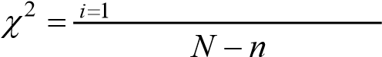 (10)

where *MR* pre,i is the *i*th predicted moisture ratio found using drying model, *MR* exp,i is the *i*th experimental moisture ratio calculated using, *N* is the number of observations, and *n* is the number of a model’s constants.

The mathematical modelling used for the experiment is given by table 2.

|  |  |  |  |
| --- | --- | --- | --- |
| MODEL  NUMBER | MODEL NAME | MODEL  EQUATION | REFERENCES |
| 1 | Lewis/Newton | MR = expt(-kt) | Ayensv(1997), Ozden and Denves (1999) |
| 2 | Henderson and Pabis | MR= a*expt(-kt) | Kabganian |
| 3 | Logarithmic | MR = aexpt(-kt+c) | E KavakAkpinar  ( 2003 ) |
| 4 | Page | MR= expt(-ktn) | Diamante and Munro  ( 1993 ) |
| 5 | Wang and Singh | MR= 1+ at+bt2 | Midilli A, Kucuk H |

Table 2: Different models used for solar drying analysis